6. GPO

Introduction

**Login**

The login credential for all server and client machines:

Username: Administrator / user

Password: Skill39@Lyon

**Network Topology**

This will be the network topology that will be referenced for setting up the infrastructure.

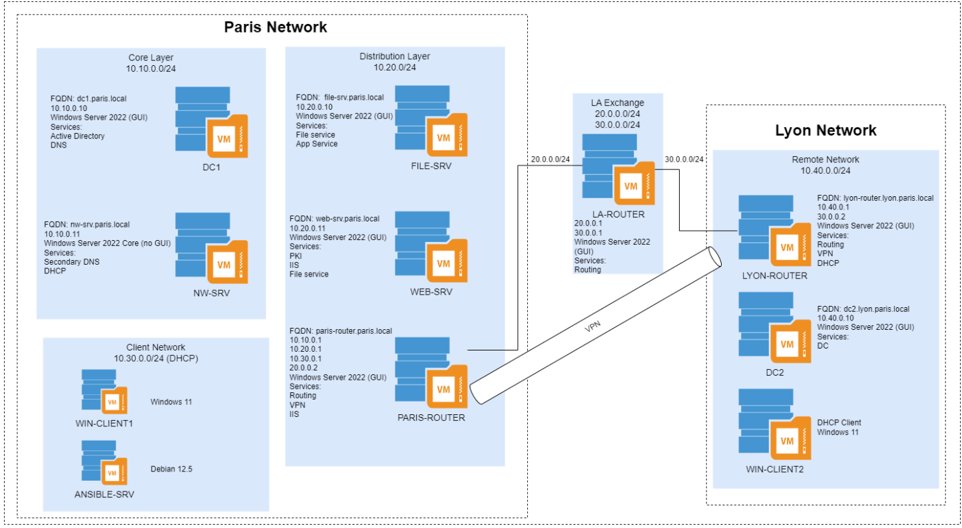

# DESKTOP

**Banner**

In GPO Management, go to Computer Configuration -> Policies > Windows Settings > Security Settings > Local Policies > Security Options

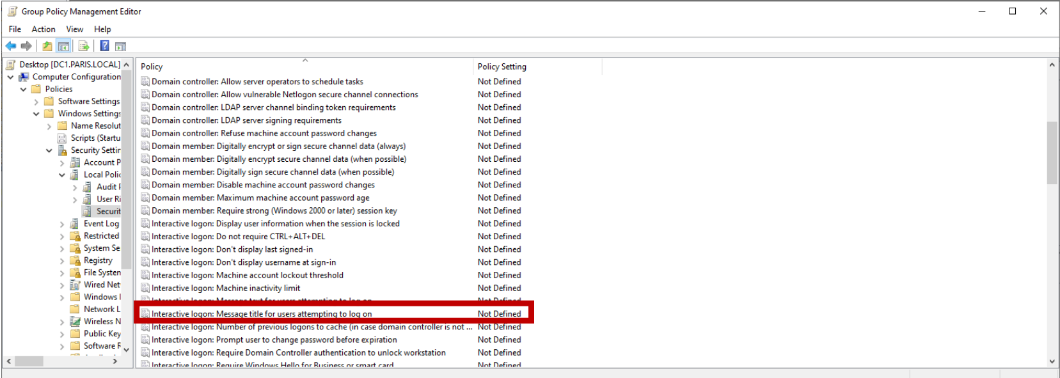

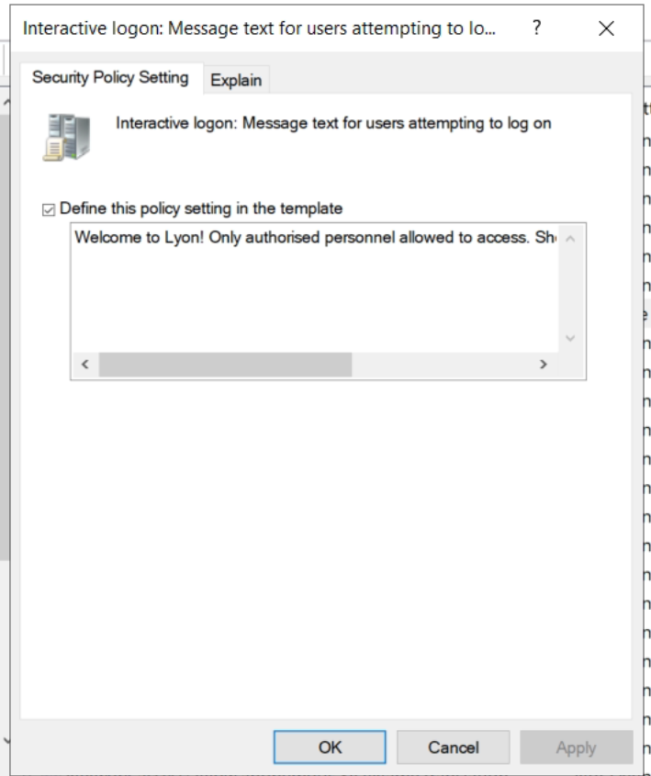

**System Environment Variable**

Computer Configuration > Preferences > Windows Settings > Environment

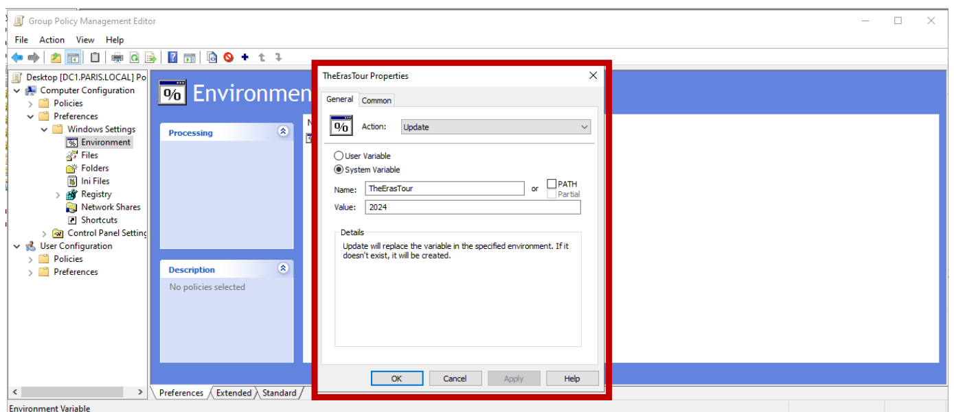

**Disable Local Administrator**

Computer Configuration > Policies > Windows Settings > Security Settings > Local Policies > Security Options

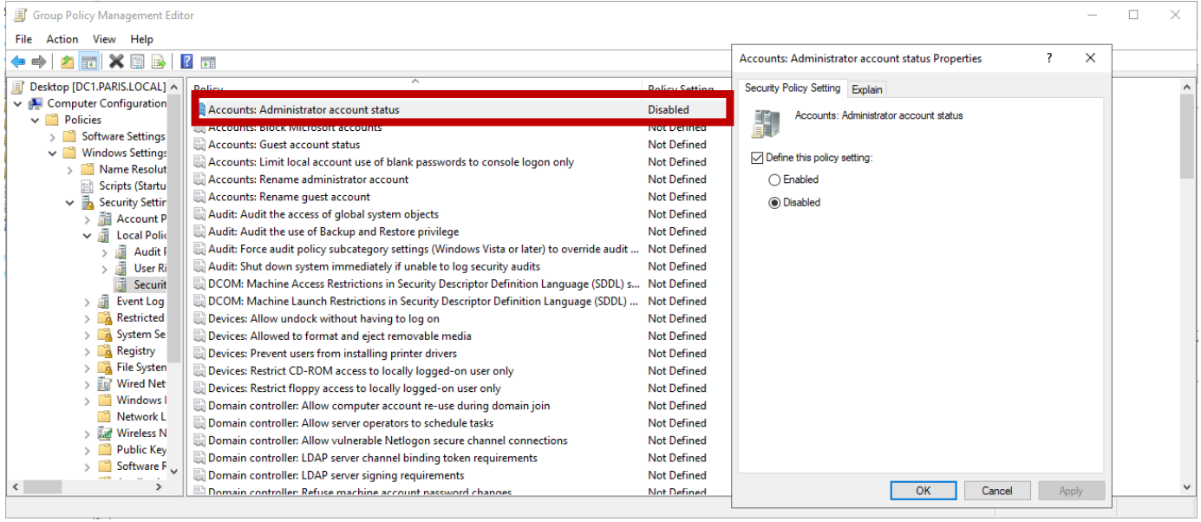

**Prevent LM Hash from being stored local**

Computer Configuration -> Policies > Windows Settings > Security Settings > Local Policies > Security Options

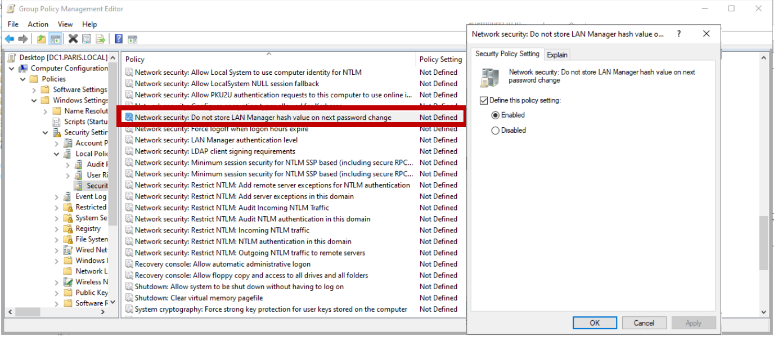

**Check Update every Friday 13:00**

Computer Configuration > Policies > Administrative Templates > Windows Components > Windows Update

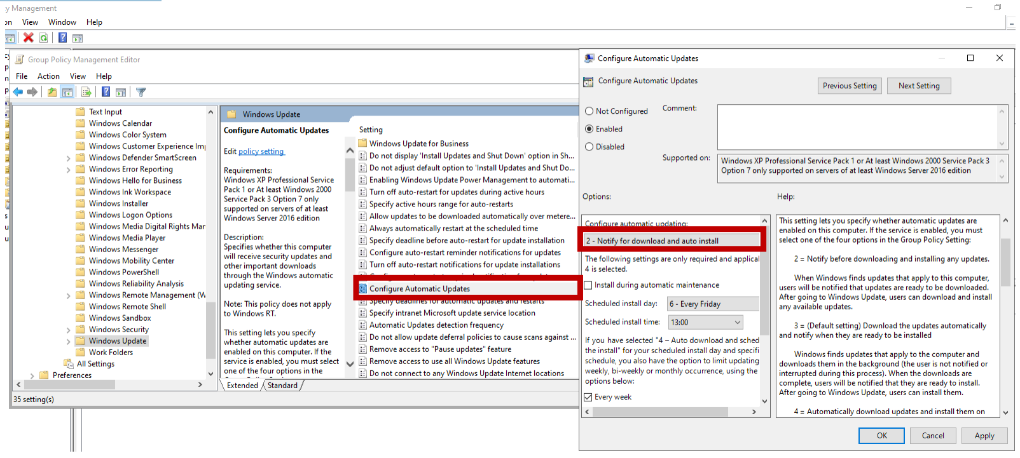

# TECH

**Auto Launch Powershell**

User Configuration -> Administrative Templates -> System -> Logon

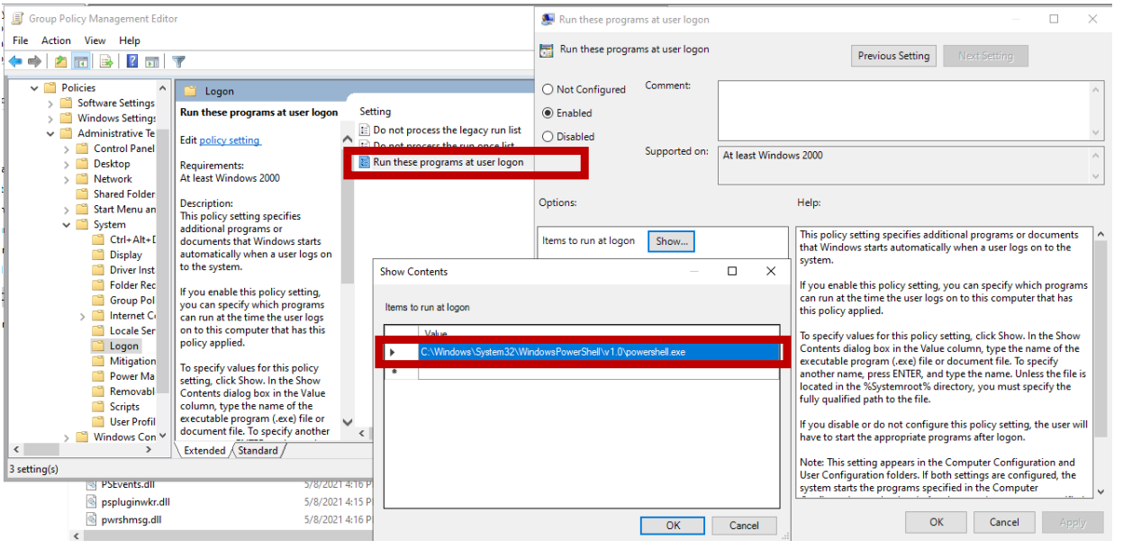

# NOTECH

**Disable ability to edit registry**

User Configuration > Policies > Administrative Templates > System

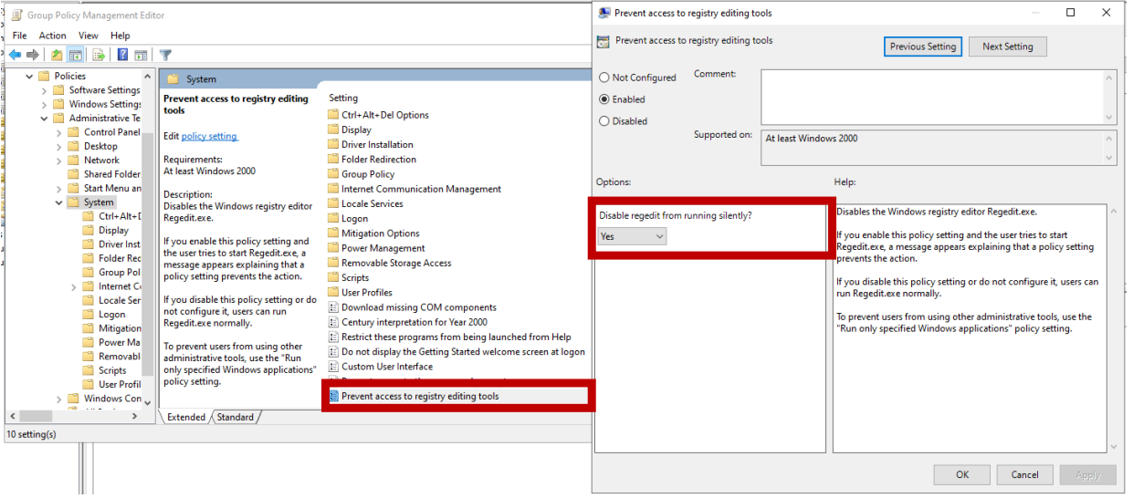

**Disable cmd and powershell**

User Configuration > Policies > Administrative Templates > System

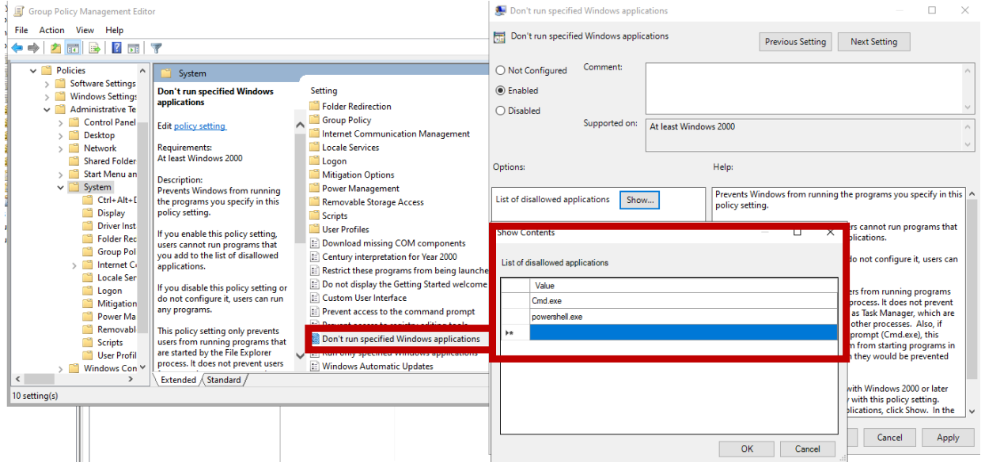

**Disable run**

User Configuration > Policies Administrative > Start Menu and Task Bar

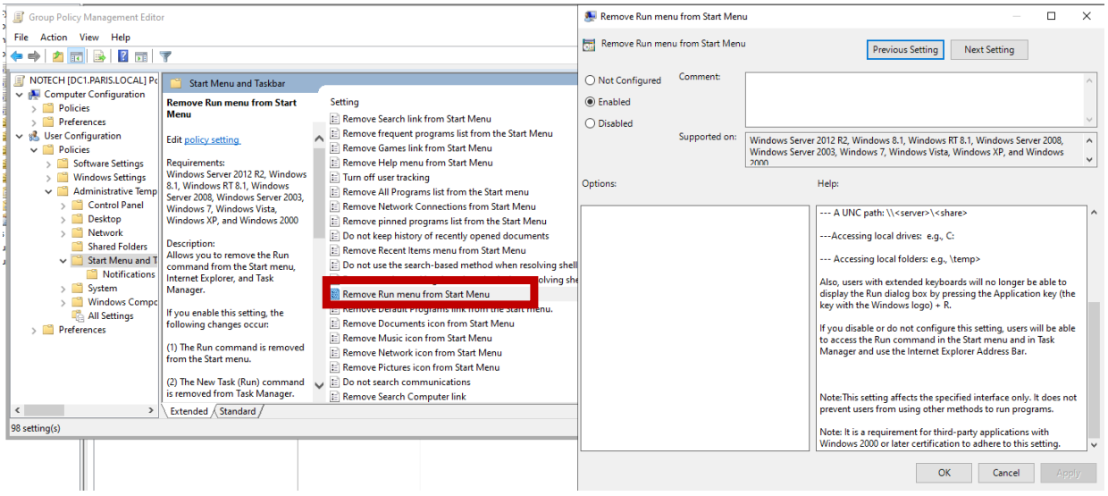

**Turn off File History**

Computer Configuration > Policies > Administrative Templates > Windows Components > File History

